**Water Quality Predictor**

Submitted in partial fulfillment of the requirements

of the degree of

Bachelor of Engineering in

Artificial Intelligence and Data Science

by

***Parth Suryavanshi***

***Shreya Singh***

***Shruti Devlekar***

***Yash Sarang***

Under the guidance of

**Dr. Anjali Yeole**



**Department of Artificial Intelligence and Data Science**

**Vivekanand Education Society’s Institute of Technology**

**2022-2023**

**Department of Artificial Intelligence and Data Science**

**CERTIFICATE**

This is to certify that **Mr. Yash Sarang, Ms. Shruti Devlekar, Mr. Parth Suryavanshi, Ms. Shreya Singh** of Third Year of Artificial Intelligence and Data Science studies at the University of Mumbai has satisfactorily presented the Mini Project entitled **Water Quality Predictor** as a part of the MINI-PROJECT for Semester-V under the guidance of **Dr. Anjali Yeole** in the year 2022-2023.

Date: 25/04/23

**(Name and sign) (Name and sign) (Name and sign)**

**Head of Department Supervisor/Guide Examiner**

**Department of Artificial Intelligence and Data Science**

**DECLARATION**

We, ***Parth Suryavanshi,*** ***Shreya Singh, Yash Sarang, and Shruti Devlekar*** from ***D11AD***, declare that this project represents our ideas in our own words without plagiarism, and wherever others' ideas or words have been included, we have adequately cited and referenced the original sources.

We also declare that we have adhered to all principles of academic honesty and integrity and have not misrepresented or fabricated or falsified any idea/data/fact/source in our project work.

We declare that we have maintained a minimum of 75% attendance, as per the University of Mumbai norms.

We understand that any violation of the above will be cause for disciplinary action by the Institute.

Yours Faithfully

1. ***Shruti Devlekar.***
2. ***Parth Suryavanshi.***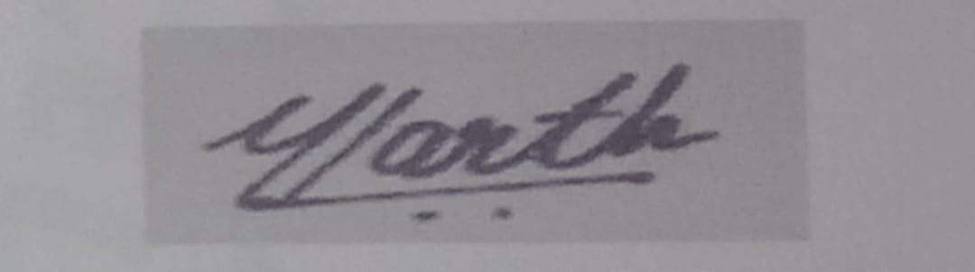
3. ***Shreya Singh.***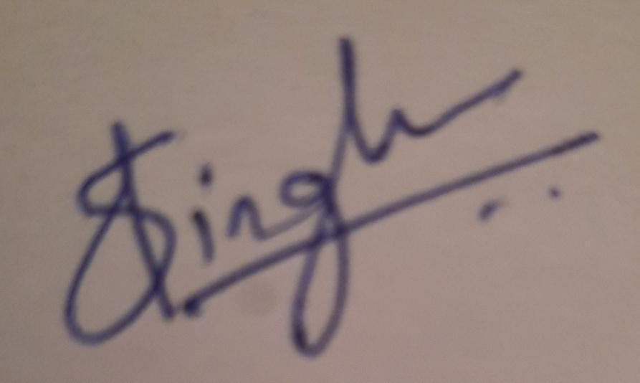
4. ***Yash Sarang.***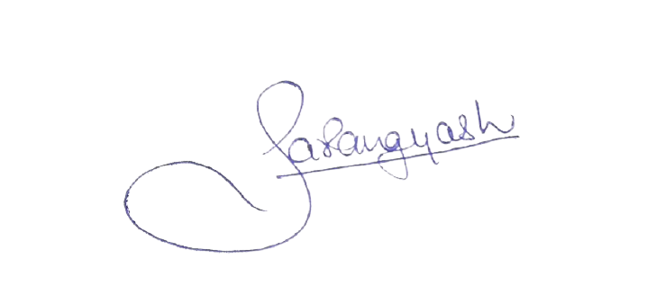

**Date:** 17/04/2023

**Acknowledgment**

We are thankful to our college **Vivekanand Education Society’s Institute of Technology** for considering our project **Water Quality Predictor and Usage Suggestor** and extending help at all stages needed during our work of collecting information regarding the project.

It gives us immense pleasure to express our deep and sincere gratitude to our Guide, **Dr. Anjali Yeole** for her kind help and valuable advice during the development of the project synopsis and for her guidance and suggestions.

We are deeply indebted to the Vice-Principal and Head of the Artificial Intelligence and Data Science Department **Dr. M. Vijayalakshmi** and our Principal **Dr. J.M. Nair** for giving us this valuable opportunity to do this project.

We express our hearty gratitude to them for their assistance without which it would have been difficult in finishing this project synopsis and project review successfully.

We convey our deep sense of gratitude to all teaching and non-teaching staff for their constant encouragement, support, and selfless help throughout the project work. It is a great pleasure to acknowledge the help and suggestion we received from the Department of Artificial Intelligence and Data Science.

## Table of Contents

* Abstract 6

1. Introduction 7

1.1 Introduction

1.2 Problem Statement

1.3 Objectives 8

1.4. Scope

2. Literature Survey 9

2.1 Literature/Techniques Studied

2.2 Papers/Findings 13

3. Dataset 14

3.1 Description of the Dataset

3.2 Data collection methodology

3.3 Exploratory Data Analysis

3.4 Feature Extraction 18

3.5 Statistical Tests 19

4. Analysis and Design ` 21

4.1 Analysis of the system

4.2 Proposed Solutions

4.3 Prototype design of the proposed system 22

5. Results and Discussion 25

6. Conclusion and Future Work

* References 26

**Abstract**

Water Quality Evaluation and efficient treatment methods play a crucial function in the efficient and sustainable use of water resources. With increasing water demands and concerns about water scarcity and contamination, there is a growing need to predict water quality and identify appropriate treatment methods. In this review paper, we provide a comprehensive overview of the status quo of water quality prediction, treatment method prediction, and use case classification. We examine the different methods used to predict water quality, including statistical models, and Machine learning algorithms. We also provide an overview of the methods used to predict the most appropriate treatment methods. Additionally, we examine the various use cases for any type of water in general. The findings of this review highlight the importance of accurate water quality prediction and treatment method prediction in ensuring the efficient and sustainable use of water resources, and the need for further research in this field. In addition to examining the existing approaches, we also developed a theoretically ideal model to predict use cases with or without treatment for any type of water. Our model is a hybrid approach of the previous studies done by researchers and their findings to enhance the results.

**Keywords:** Water quality evaluation, efficient water treatment, water use case prediction.

## 1. Introduction

### 1.1 Introduction

Water is a vital resource for all forms of life, and its quality is critical in determining its usability. With increasing water demand, concerns about water scarcity and contamination have become more important than ever. Therefore, managing water resources efficiently and sustainably is essential to accurately predict water quality and identify appropriate treatment methods.

This review paper aims to provide a comprehensive overview of the current state of water quality prediction, treatment method prediction, and use case classification. Various methods used for predicting water quality and treatment methods, including statistical models, Machine learning algorithms, and remote sensing techniques, have been examined. Additionally, the paper explores different use cases for industrial water, such as process water, cooling water, and boiler feed water, and their impact on water treatment and management.

The findings of this review highlight the importance of accurate water quality prediction and treatment method prediction in ensuring efficient and sustainable use of water resources. This paper aims to make a valuable contribution to ongoing efforts to manage water resources and address the challenges posed by water scarcity and contamination.

To address this issue, our paper proposes a model for predicting water quality using various Machine learning algorithms, such as decision trees, artificial neural networks, and improved decision trees. The paper also intends to forecast the most effective water treatment methods, followed by the best use case classification or suitability prediction based on the quality of the data. This paper's goal is to develop an automated and comprehensive solution that can accurately evaluate the Water quality and suggest optimal use cases and treatment processes.

### 

### 1.2 Problem Statement

The problem we are addressing is the lack of a comprehensive solution that can accurately predict and classify water quality and suggest the most optimal use cases and treatment processes. Currently, most water quality evaluation methods are manual and time-consuming, which can be impractical for large water bodies. Moreover, the lack of a standardized water quality evaluation system and treatment processes can result in the implementation of sub-optimal solutions. Therefore, there is a need for an automated and comprehensive solution that can accurately evaluate the Water quality and suggest optimal use cases and treatment processes.

### 1.3 Objectives

This project is made with the objective to achieve the following sustainable development goals :

* Clean Water and Sanitation - This model can predict the water quality of a water body, thus determining whether the water is safe to drink or not.
* Good Health and Well-Being - Since this model determines the safety of water, it will lead to fewer people drinking unsafe, contaminated water.

### 1.4 Scope

This application has a wide scope of applications. It can be used by a citizen to check the quality of water coming into his home. It can also be useful to government officials who can monitor the water quality in their respective regions. This can further be of use to environment enthusiasts and researchers who can track the water quality all over India.

## 2. Literature Survey

### 2.1 Literature/Techniques Studied

**AI in Water Quality Prediction**

Water Quality And Its Requirement. Water quality is essential for its suitability for designated uses such as drinking, cleaning, fish farming, agriculture, or industrial use. Each Use has specific chemical, physical, and biological standards necessary to fulfill its purpose. For example, water used for swimming and drinking requires stricter standards than water used in industry or agriculture.  
 The use of Artificial Intelligence (AI) in water quality prediction can address challenges faced in the water treatment industry. AI models can predict water quality more accurately using historical water quality data and relevant environmental factors. This can help in the efficient and sustainable use of water resources.

**Previous Work.** "Data-driven Water Quality Analysis and Prediction: A Survey" by G. Kang, J. Z. Gao, and G. Xie,[1] provide an overview of the various data-driven approaches used for water quality analysis and prediction. The paper reviews various statistical models, Machine learning algorithms, and remote sensing techniques used for water quality prediction. The paper highlights the advantages and limitations of different techniques and the need for further research in the field.

ML Techniques implemented:

Artificial Neural Network (ANN), Radial Basis Function Network (RBFN), Deep Belief Network(DBN), Decision Tree (DT), Improved Decision Tree (IDT), and Least Squares Support Vector Machine(LSVM).

"A review of artificial intelligence-based methods for water quality monitoring and prediction" by Zhang et al.[2] provides a comprehensive overview of AI-based methods used for water quality monitoring and prediction. The paper focuses on the application of Machine learning algorithms, such as decision trees, random forests, artificial neural networks, and support vector machines, for water quality prediction. The authors also discuss the challenges associated with water quality prediction, such as data availability and accuracy, and the need for further research.

ML Techniques implemented:

Artificial Neural Networks (ANNs), Support Vector Machine (SVM), Decision Tree (DT), and Artificial Bee Colony Algorithm (ABC).

"Artificial intelligence-based water quality prediction using Machine learning algorithms: a review" by Raza and Kim[3] focuses on the use of Machine learning algorithms for water quality prediction. The paper reviews various algorithms, such as decision trees, random forests, artificial neural networks, and support vector machines, and their application in water quality prediction. The authors also discuss the challenges associated with water quality prediction and the need for further research.

ML Techniques implemented:

Artificial Neural Networks (ANNs), Support Vector Machines (SVM), and Random Forest (RF).

"Artificial Intelligence for Water Quality Monitoring and Prediction: a Review" by Liu and Li[6], similarly focuses on the use of AI in water quality monitoring and prediction. The authors provide a detailed overview of the different AI-based methods used for this purpose, including Machine Learning algorithms and other data-driven methods.

ML Techniques implemented:

Artificial Neural Networks (ANNs), Support Vector Machine (SVM), Decision Tree (DT), Random Forest (RF), and K-Nearest Neighbor (KNN).

The common theme in these papers is the use of AI and Machine learning algorithms for water quality prediction and the need for further research in the field. The papers also highlight the importance of accurate water quality prediction in ensuring water resources’ efficient and sustainable use.

**AI in Water Treatment**

Use and Requirement of AI. AI has become essential in water treatment due to the growing demand for clean and safe water and the need for efficient use of limited resources. AI can predict water quality and identify appropriate treatment methods, leading to improved water management and conservation. AI algorithms can analyze vast amounts of data, including real-time water quality data, to provide insights not possible with manual methods.

Furthermore, AI can optimize treatment processes, reducing waste and energy consumption. Integrating AI into water treatment can increase efficiency, reduce costs, and ensure the safe and sustainable use of water resources.

**Previous Work.** “Deep learning models for wastewater treatment” by Wei, H., Zhang, H., & Fang, J. [9] presents the application of deep learning models in predicting the operational process of wastewater treatment plants. The authors trained and evaluated several deep learning models such as multilayer perceptron (MLP), long short-term memory (LSTM), and gated recurrent unit (GRU) to predict the treatment performance of wastewater treatment plants. The results showed that the GRU model outperformed the MLP and LSTM models in terms of prediction accuracy.

Techniques Implemented-

Deep Learning Models, Multilayer Perceptron (MLP), Long Short-Term Memory (LSTM), Gated Recurrent Unit (GRU)

“Real-time operational process prediction in wastewater treatment” by Yuan, Y., Wang, W., & Li, Y. [10] describes the implementation of Machine learning algorithms for real-time operational process prediction in wastewater treatment plants. The authors used five algorithms, including decision trees, random forests, support vector machines, k-nearest neighbors, and artificial neural networks, to predict the treatment efficiency of wastewater treatment plants. The results showed that the artificial neural network had the best performance in terms of prediction accuracy.

Techniques Implemented-

Decision trees(DT), Random Forests(RF), Support vector machines(SVM), k-nearest neighbors(KNN), and artificial neural networks(ANN).

“Artificial intelligence-based wastewater treatment plant optimization” by Chang, X., & Dai, Y. [11] provides a comprehensive review of the application of artificial intelligence in optimizing the operational process of wastewater treatment plants. The authors discussed several AI techniques, including artificial neural networks, decision trees, genetic algorithms, and fuzzy logic, and their applications in wastewater treatment plant optimization.

Techniques Implemented-

Artificial Intelligence-based optimization, Artificial neural networks(ANN), Decision tree(DT), Genetic algorithms, Fuzzy logic.

“Artificial intelligence-based wastewater treatment prediction model based on improved particle swarm optimization algorithm” by Liu, X., Guo, Y., & Li, S. [12] proposes a new wastewater treatment prediction model based on an improved particle swarm optimization algorithm and artificial intelligence techniques. The authors applied the model to predict the treatment performance of a wastewater treatment plant and showed that the model achieved better performance compared to other traditional prediction models.

Techniques Implemented-

Improved particle swarm optimization algorithm

In “Deep learning-based prediction of the treatment effect of anaerobic sequencing batch reactor for municipal wastewater treatment” by Wang, X., Jiao, L., Zhang, X., & Li, B. [14], the authors used deep learning algorithms to predict the treatment effect of an anaerobic sequencing batch reactor for municipal wastewater treatment. They trained and tested the model on real-world data collected from a wastewater treatment plant in China. The results showed that the deep learning-based model was capable of accurately predicting the treatment effect, with high correlation coefficients and low mean absolute error values. The model was also able to capture the nonlinear and complex relationships between the input variables and the treatment effect.

In “Artificial intelligence-based wastewater treatment plant operational process prediction using convolutional neural network” by Li, X., Li, Y., & Liu, J. [17], the authors have used a convolutional neural network (CNN) to predict the operational process in a wastewater treatment plant. They collected data on influent flow rate, pH, chemical oxygen demand, and temperature and used it to train and test the CNN model. The results showed that the CNN model was capable of accurately predicting the operational process, with high correlation coefficients and low mean absolute error values. The authors also demonstrated the effectiveness of the model in real-world applications by using it to control the wastewater treatment process in a pilot-scale wastewater treatment plant.

Techniques Implemented-

Convolutional Neural Network(CNN), Artificial Intelligence

## 

**AI in Use Case**

Use and Requirement of AI. AI can improve water treatment prediction by analyzing large amounts of data to find patterns and correlations, predicting water quality, and identifying the best treatment method based on costs and available water supply. AI models can learn and improve over time, making water treatment prediction more accurate and efficient while minimizing costs and environmental impact. Overall, AI can support sustainable water management, improve water quality, and reduce costs.

Industrial processes require specific types of water, such as deionized, distilled, treated, untreated, or recycled water, depending on their requirements. For example, deionized or distilled water may be needed for some processes, while others may use treated or untreated municipal water. In some cases, recycled or reused water may be used in industrial processes. The choice of water type depends on the process's specific requirements and the quality of water needed for the process.

**Previous Works.** “Artificial intelligence-based water usage prediction in the chemical industry” by Zhang, H., Wu, J., & Fan, X. [18] presents a case study of using artificial intelligence (AI) for water usage prediction in the chemical industry. The authors use support vector regression (SVR) and artificial neural network (ANN) models to predict water usage and compare the results. The results show that the ANN model has a higher accuracy compared to the SVR model.

Techniques Implemented-

Support Vector Regression (SVR), Artificial Neural Network

“Predictive control for industrial water usage based on Machine learning algorithms” by Chen, S., Dong, X., & Jia, J. [19] presents a study using Machine learning algorithms for industrial water usage prediction. The authors use linear regression and support vector regression (SVR) models for prediction and compare the results. The results show that the SVR model has a better prediction performance compared to the linear regression model.

Techniques Implemented-

Linear regression, Support vector regression (SVR)

“An improved water usage prediction method for industrial production based on deep learning” by Xiong, H., He, H., & Lu, Y. [20] presents a study on using deep learning for industrial water usage prediction. The authors use a deep neural network (DNN) model and improve the prediction performance through feature selection and model fine-tuning. The results show that the improved DNN model has great accuracy and effectively predicts industrial water usage.

Techniques Implemented- Deep Neural Networks

“Water usage prediction in the chemical industry based on an improved particle swarm optimization algorithm” by Liu, X., Guo, Y., & Li, S. [21] presents a study using a particle swarm optimization (PSO) algorithm for industrial water usage prediction. The authors use the PSO algorithm to optimize the parameters of a support vector regression (SVR) model and improve the prediction performance. The results show that the optimized SVR model has great accuracy and effectively predicts industrial water usage.

Techniques Implemented -

Particle swarm optimization algorithm, Support vector regression

“A novel water-use prediction method based on an extreme learning machine and multi-objective optimization algorithm” by Sun, S., Chen, W., & Lei, Y.” [25] present a water-use prediction model using an extreme learning machine and a multi-objective optimization algorithm. The model is tested and applied on a real-world water use dataset, showing promising results.

Techniques Implemented -

Extreme Learning Machines, Multi-objective optimization algorithm

### 2.2 Papers/Findings

The common theme in these papers is the use of AI and Machine learning algorithms for water quality prediction and the need for further research in the field. The papers also highlight the importance of accurate water quality prediction in ensuring water resources’ efficient and sustainable use.

The choice of Treatment method depends on the type and concentration of contaminants and desired outcome. Treatment processes may be used alone or in combination to achieve the desired water quality. Heavy metals are common inorganic pollutants that can be toxic, carcinogenic, and non-biodegradable. Various strategies, including adsorption, membrane-, chemical-, electric-, and photocatalytic-based therapies, can be used for Heavy metal reduction from Wastewater sources.

The result of using AI in water usage prediction has shown promising results in the following manner:

1. Improved Accuracy: AI algorithms such as deep learning and machine learning can process vast amounts of data in real-time and make predictions with high accuracy.
2. Efficient Water Management: AI can help optimize the use of water resources by predicting water usage patterns and identifying areas for improvement. This leads to better water management and reduces waste.
3. Cost-Effective Solutions: AI can help save costs by reducing the need for manual monitoring and data collection, and by providing more accurate predictions and insights into water usage patterns.
4. Better Decision Making: AI can provide real-time insights into water usage patterns, allowing organizations to make informed decisions about water usage, treatment, and allocation.

## 

## 3. Data Set

### 3.1 Description of the data set

Our dataset would include the water properties of

1. pH value

2. Hardness

3. Solids (TDS-Total dissolved solids)

4. Chloramines

5. Sulfate

6. Conductivity

7. Organic_carbon

8. Trihalomethanes

9. Turbidity

10. Potability

**Fig 1. Description of the Data**

### 3.2 Data collection methodology

Data is collected from various sources. Most of which is from the [Central Pollution Control Board](https://cpcb.nic.in/nwmp-data-2019/) which has public datasets about water.

### 3.3 Exploratory data analysis

Libraries used for EDA: Matplotlib.pyplot, Seaborn, and plotly.

Steps performed :

1. Scaling down for distribution plots
2. Scatter Matrix
3. Correlation Matrix
4. Checking for Missing values
5. Distribution Plots (with Histograms)
6. Feature extraction

**1. Scaling down for distribution plots :** We observed that the data for different features are widely ranged and their distributions cannot be compared on a single scale. So we will be Scaling down the data (Standardizing) so that the distributions can be compared. Some features are in the range of 100s some in 10ks. This operation will bring down the scale in the range of ~ -3 to +3.

**2. Scatter Matrix :** To see the correlation between the features we will plot a Scatter matrix. This matrix consists of several graphs (all scatter plots) taking any 2 features as the axes. We can observe the behavior of the features and how it affects the result (Potability).

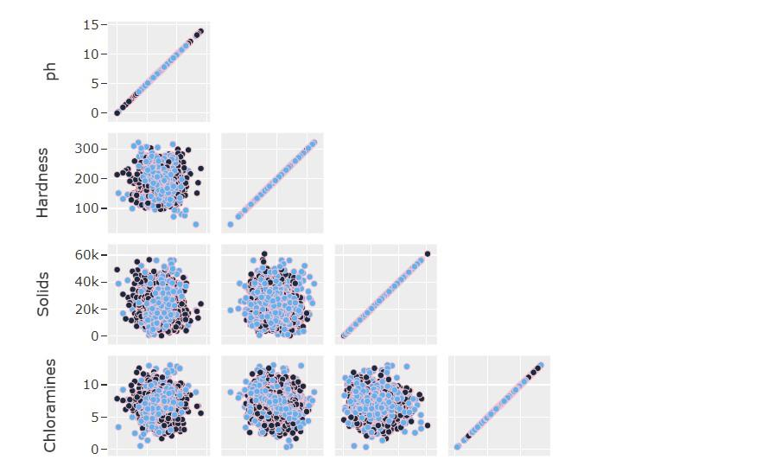

**Fig 2. Scatter Matrix**

From the scatter plot, it looks like there is no visible relation between the features. The data points are mostly randomly scattered in space. This might be the result of noisy data, or data that isn't much correlated with the result. This might lead to bad-performing models.

**3. Correlation Matrix :**

From the matrix, it looks like there is no correlation. So the features individually do not affect the result as much.

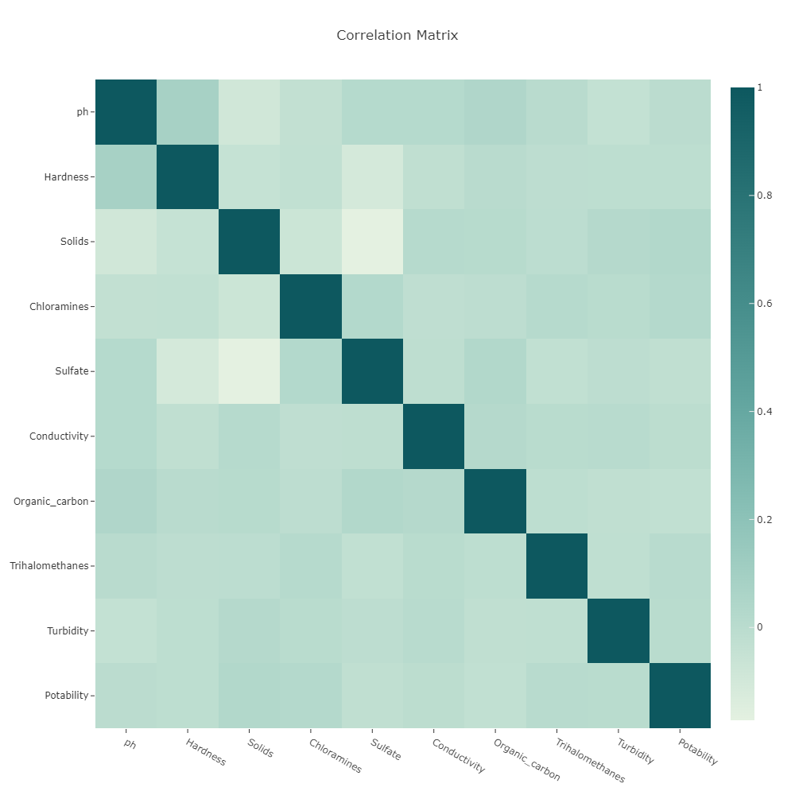

**Fig 3. Correlation Matrix**

**4. Checking for Missing Values :**

Now we check for the missing values using Heatmap.

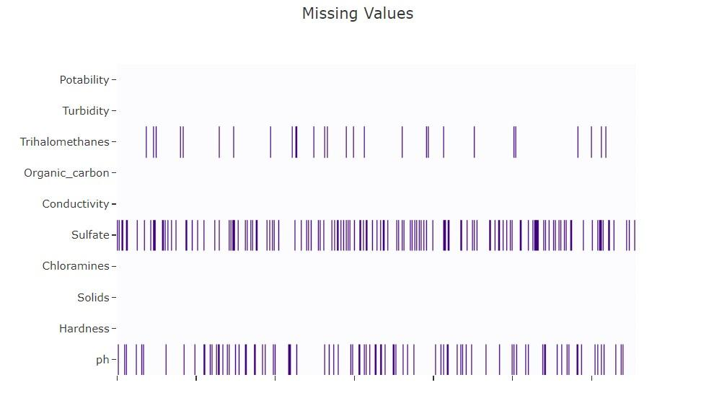

**Fig 4. visualization of Missing Values**

So there are a significant number of missing values for **Trihalomethanes**, **Sulfate,** and **pH**. These missing values can be filled using the k-nearest neighbors method.

**5. Distribution plots (with histograms) :**

We plot the distribution graphs for all the features using the histogram.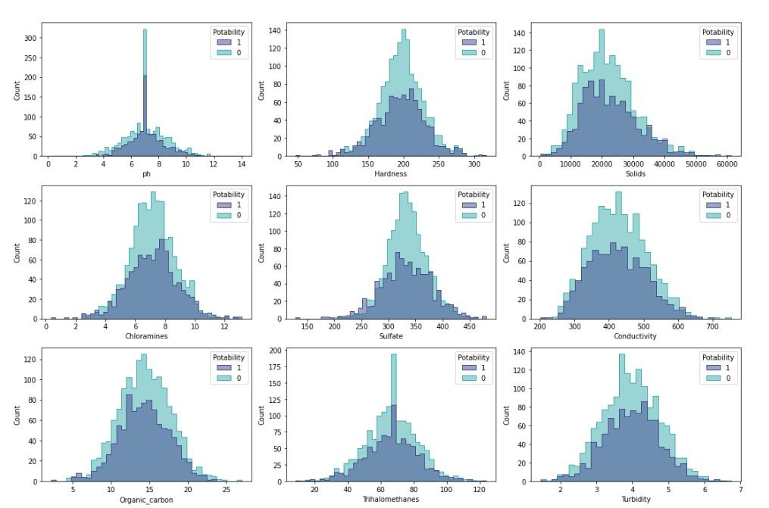

**Fig 5. Distribution plots**

### 3.4 Feature extraction

First, we check the dataset for categorical features

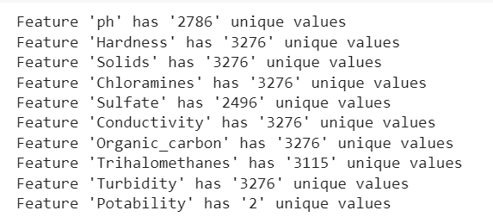

**Fig 6. Categorical Features**

We observe that one feature (Potability) is categorical while the rest are continuously numeric.

Visualizing the continuous features :

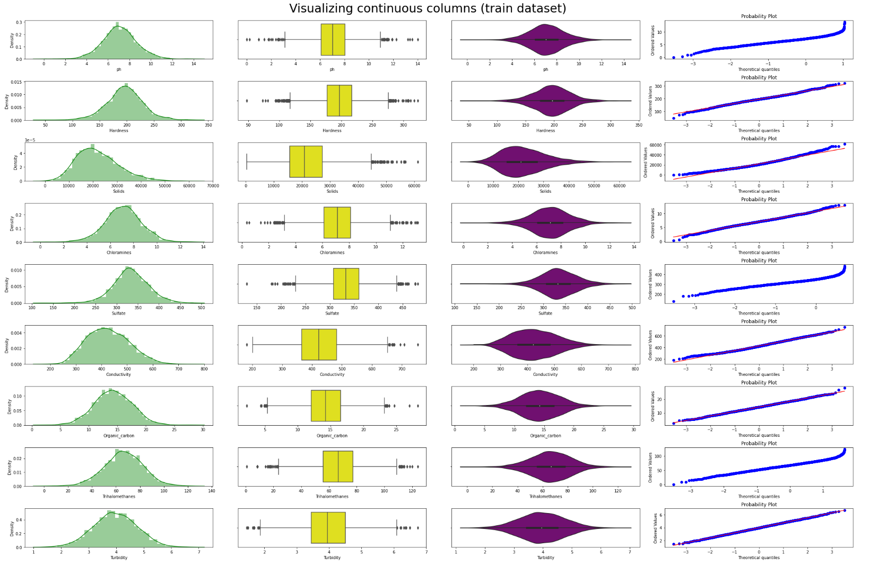

**Fig 7. Visualization of continuos features**

After analyzing these graphs, the following hypotheses are made:

1. Most features are distributed according to the normal distribution law.
2. There are minor outliers for some features.

Plotting the distribution of the target feature :

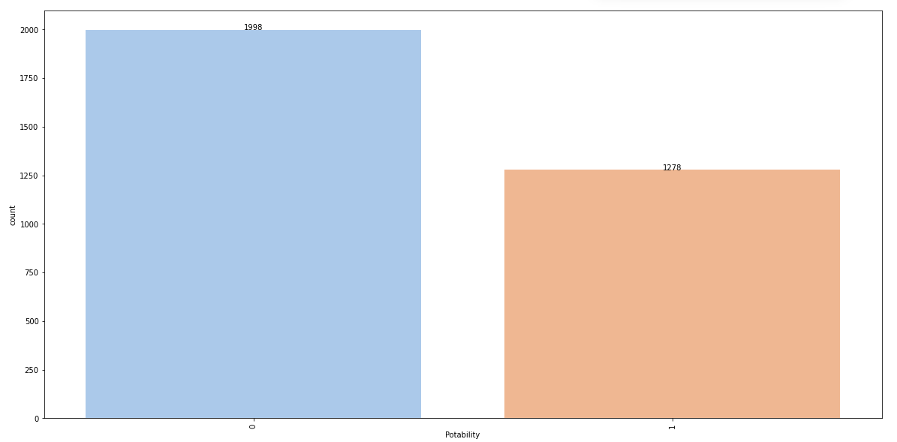

**Fig 7. Distribution of the target feature**

The plot shows that there is a clear class imbalance that needs to be eliminated we do so by creating artificial duplicates to eliminate this effect

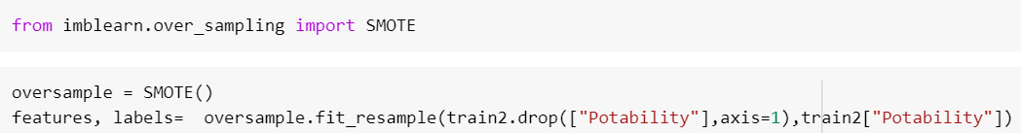

### 3.5 Statistical Tests

We then performed some statistical tests to check if the features are normally distributed.

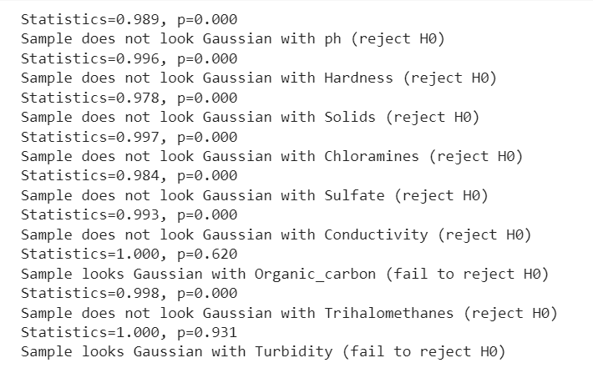

**Fig 8. Statistical Test Data**

Since most of the features were not distributed according to the normal distribution law, we used the Mann-Whitney U-test.

Since the sample distributions did not turn out to be equal, we reject the null hypothesis and decided that our final model will include all the features.We also removed outliers using sklearn’s LocalOutlierFactor.

To increase the accuracy of forecasting, we normalized the data between [0,1]

Finally, data looks like :

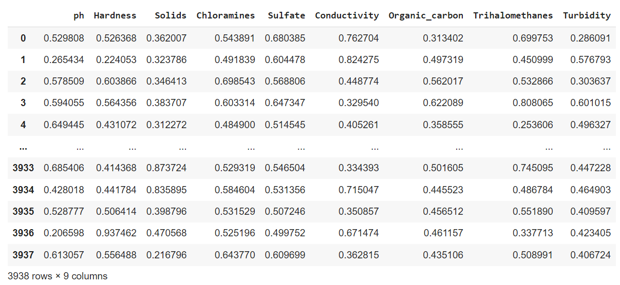

**Fig 9. Final Data Look**

## 4. Analysis and Design

### 4.1 Analysis of the system

As seen from the system architecture (on later pages), the data comes from various sources - lakes, ponds, rivers, canals, seawater, drains, and groundwater. This data is stored in the database which further undergoes EDA and feature extraction. After the data is ready, it is fed to the ML model which uses the Improved decision tree algorithm to predict the output (water quality).

The database is also connected to the web application. So, the user inputs the data according to the water source and location. This data is then worked upon by the ML model which produces the predicted output. This output is then shown in the web application to the user.

### 4.2 Proposed Solutions

The project aims to prepare a Model to predict the quality of water using factors like hardness, pH value, dissolved solids, chloramines, sulfate, carbon, etc, and tell us whether the water is safe to drink or not. This model would be then integrated into a web application using React.

Consumers like Government officials, Farmers, Private landowners, and Industry specialists would be availed of an option to upload the data of the water they have received through various sources. The prediction model would then predict the quality of the water and also its suitability through a user-friendly interface.

### 4.3 Design of the proposed system

**Fig 10. System Architecture** 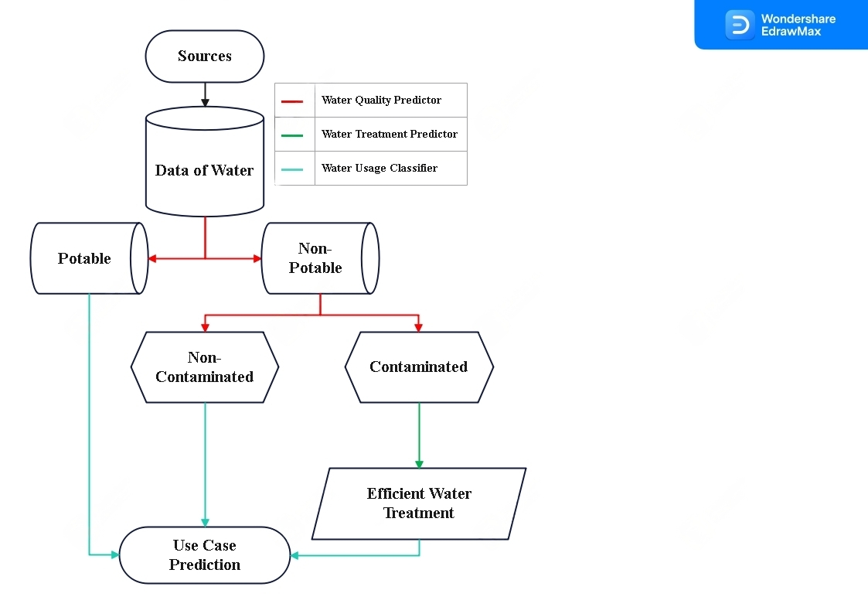

The goal of our model is to find the most efficient way to use any type of water source such as rivers, ponds, wells, reservoirs, dams, etc.

The flow of the solution i.e the system architecture is graphically depicted in Figure 10.

The data of the water would first go through the Water Quality Predictor to provide us the insights/results on the quality of the water on which we would decide whether the water is Potable or Not, if it is potable then we would run it through our Use Case Prediction model to suggest the best use cases like household work, cleaning, drinking, etc.

If Not, it would further check whether it’s contaminated or not concerning its quality derived earlier. If not it can be used for industrial uses like Cooling: Water is used for cooling in industrial processes, such as Industrial Processing, Cleaning, Boiler Feed, Fire Suppression, Agriculture, etc.

If the water is contaminated, the data will be run through our ‘Water Treatment Predictor’ which will take into account the costs of water treatment facilities, and the amount of water available and also predict the output of all the treatment methods on the specific data. Then it would provide us with the most optimal treatment method economically as well as in terms of performance.

Lastly, the output of the treatment predictor will go through the Use case predictor to also predict the use cases of that water. The aim is to determine the best use for any form of water, even if it's contaminated so that smart and optimal industrial or large-scale decisions can be made.

**Fig 11. System Architecture with DB and web Application**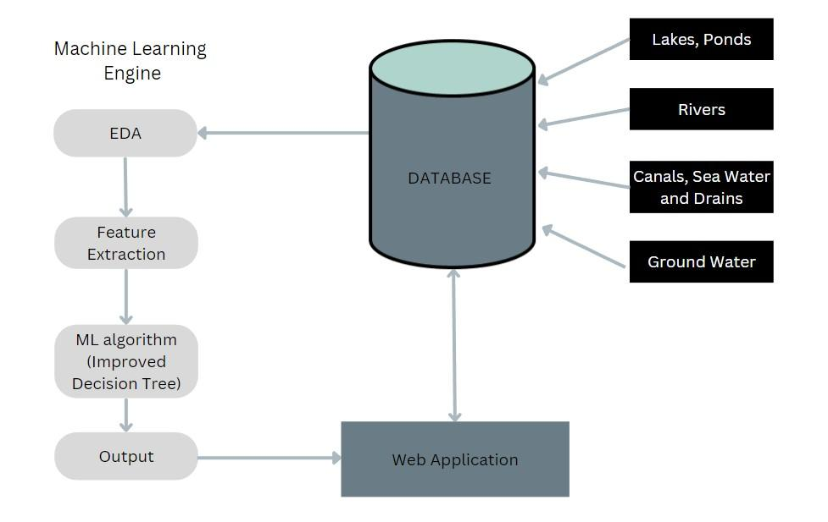

The system architecture depicts that our data which is collected from groundwater sources all over India is first preprocessed then based on the parameters of the water, its Water quality Index is calculated. The Water Quality Indices are then grouped into various classes such as ‘Excellent’, ‘Good’, ‘Fair’, ‘Marginal’, ‘Poor’.

These classes are then assigned to each row and then the predictions are made on the newly created dataset using XGBoost Classifier and Linear Regression.

The model is then connected to the frontend using streamlit. There can be two kinds of users for our application One is Naive users and other is Officials who have access to the water quality parameters. Based on the inputs provided by the users, the quality is predicted and displayed. We have also stored login info of users into a database.

Screenshots of our app which predicts water quality based on a dataset using XGBoost. Deployed using streamlit on Python

We have 2 Instances of the Implementation of our project:  
1. Water Quality Predictor

2. Water Quality, Treatment and Usage Predictor.(In Progress)

**Water Quality Predictor**

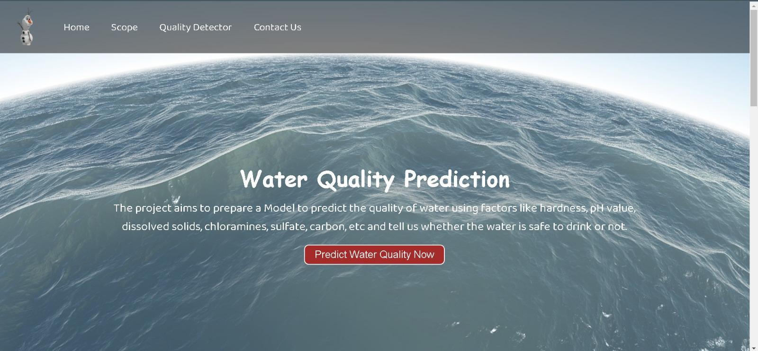

**Fig 12.1. Home page for normal users**

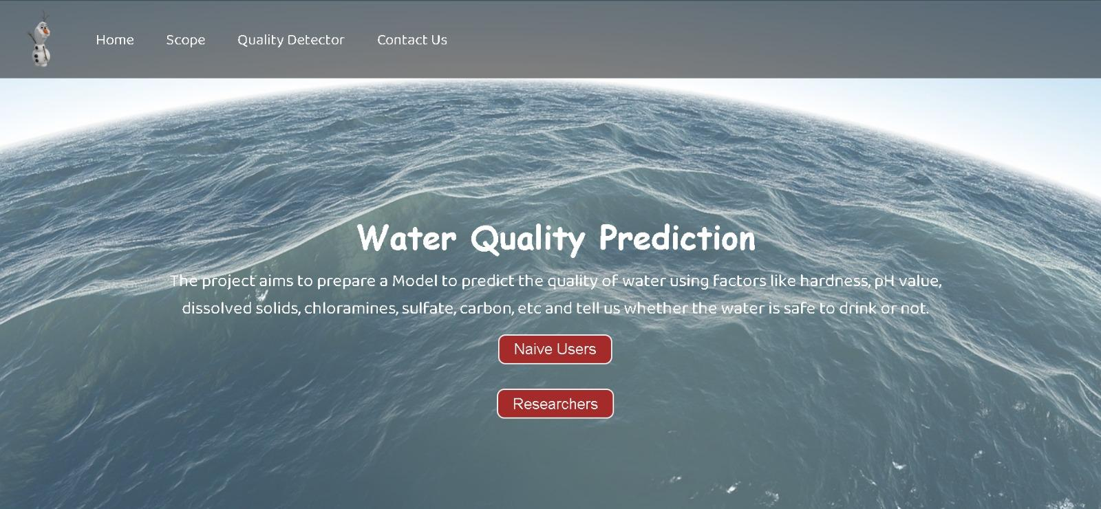

**Fig 12.2 Home page for authorized users with more functionality**

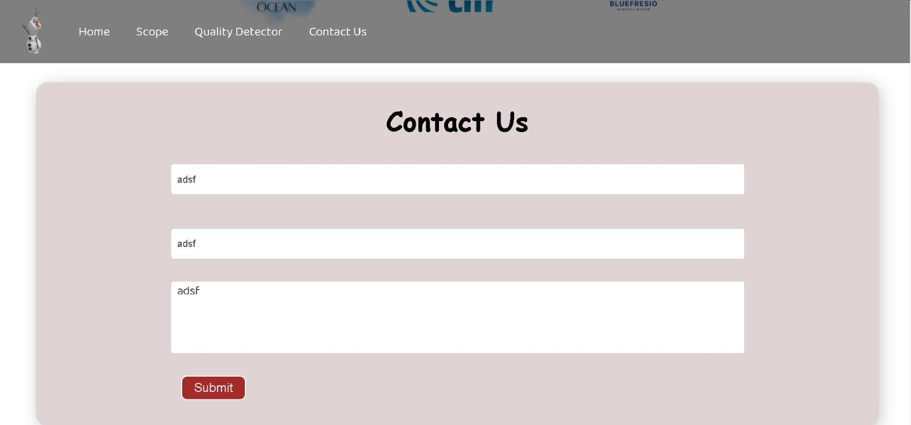

**Fig 12.3. Contact us page**

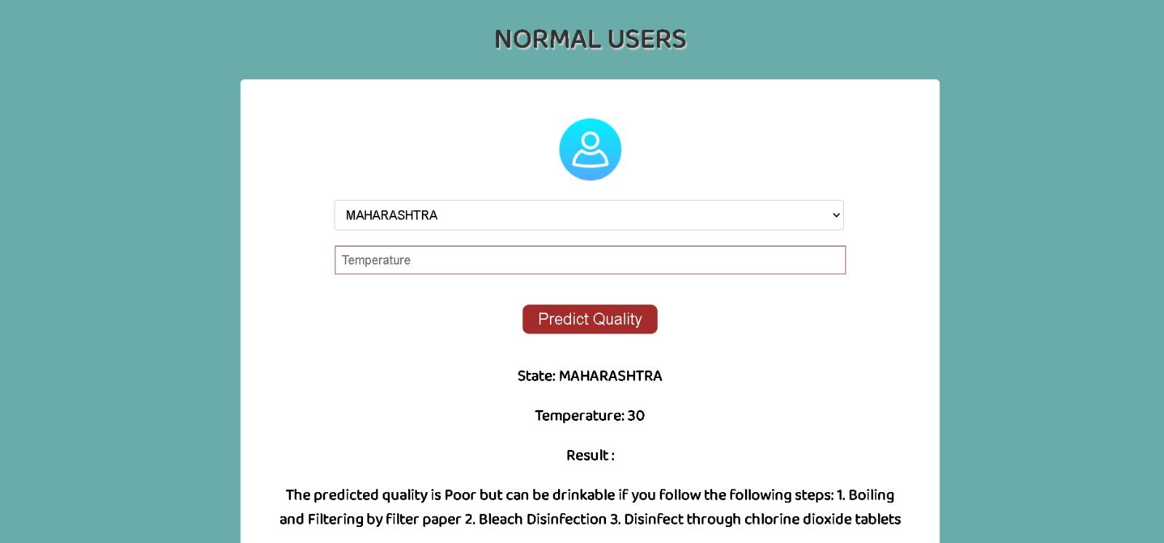

**Fig 12.4. Prediction page for naive users**

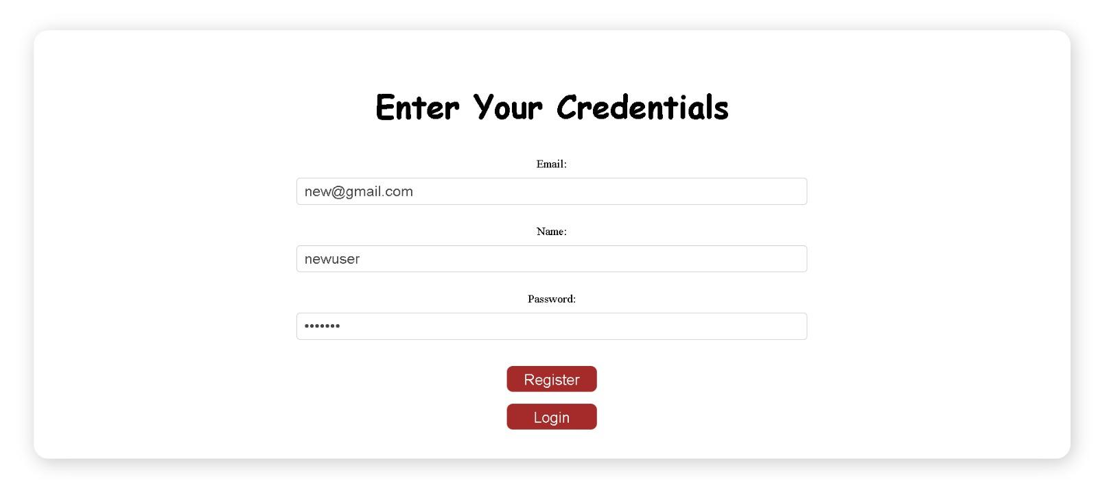

**Fig 12.5. Login page for naive users**

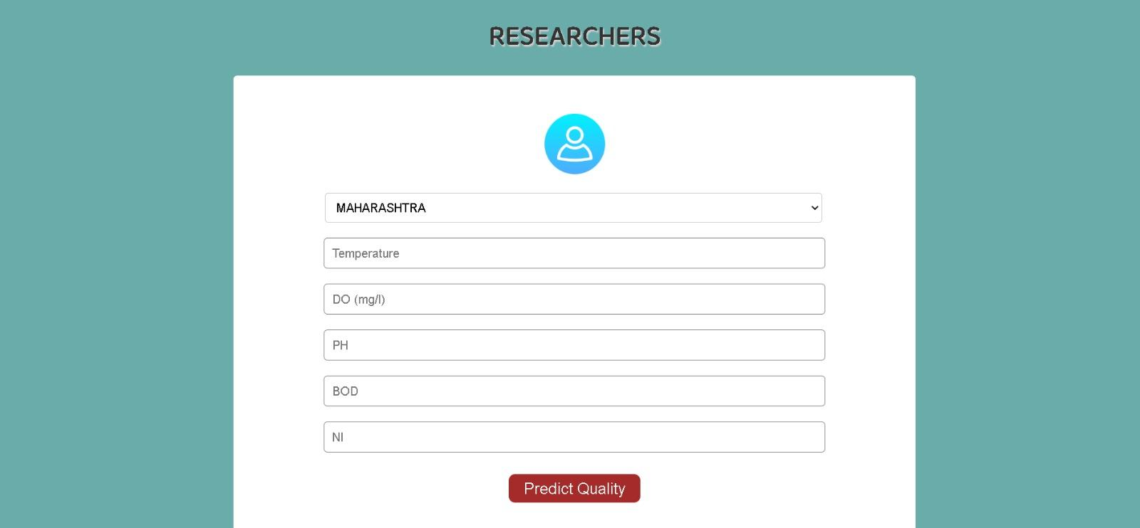

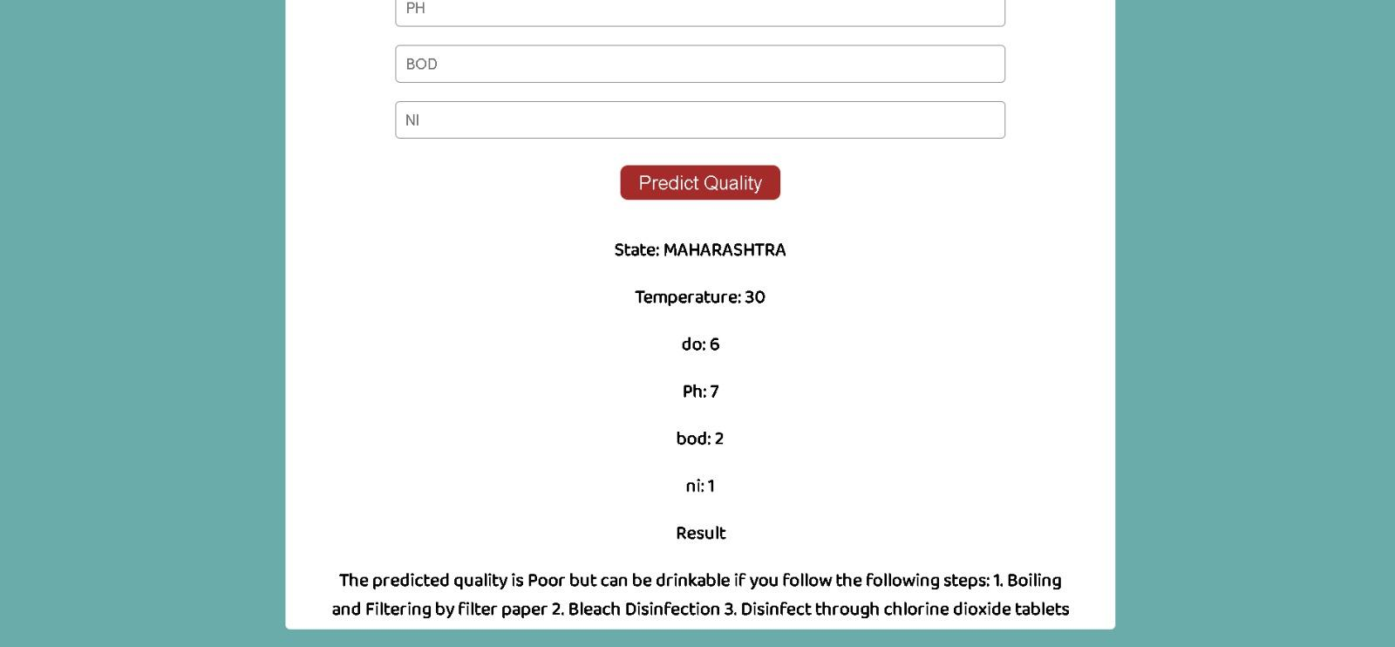

**Fig 12.6. Prediction page for officials**

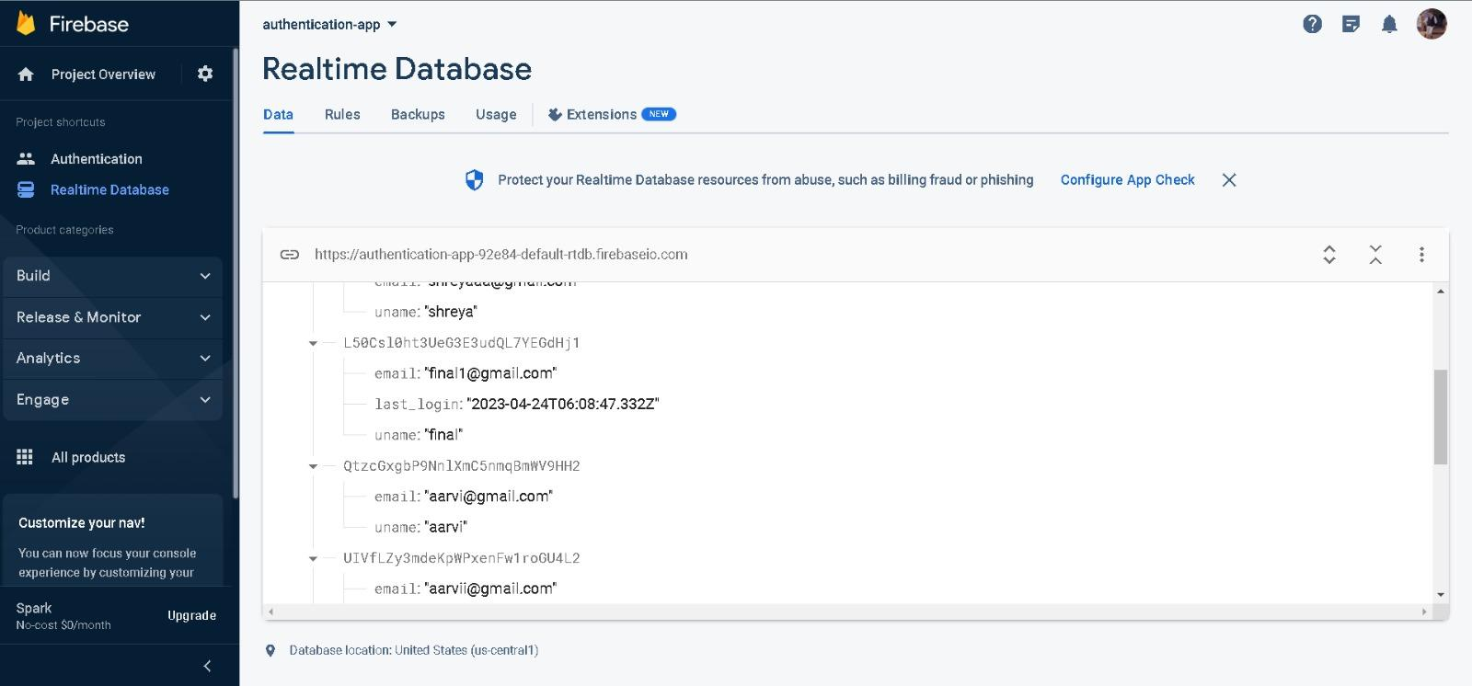

**Fig 12.7. User Login Database stored in firebase**

**~~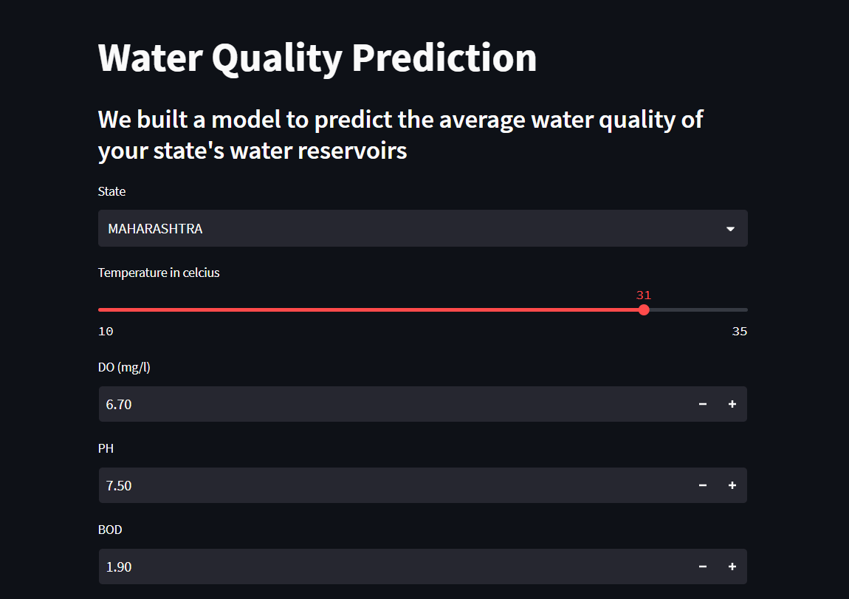~~**

~~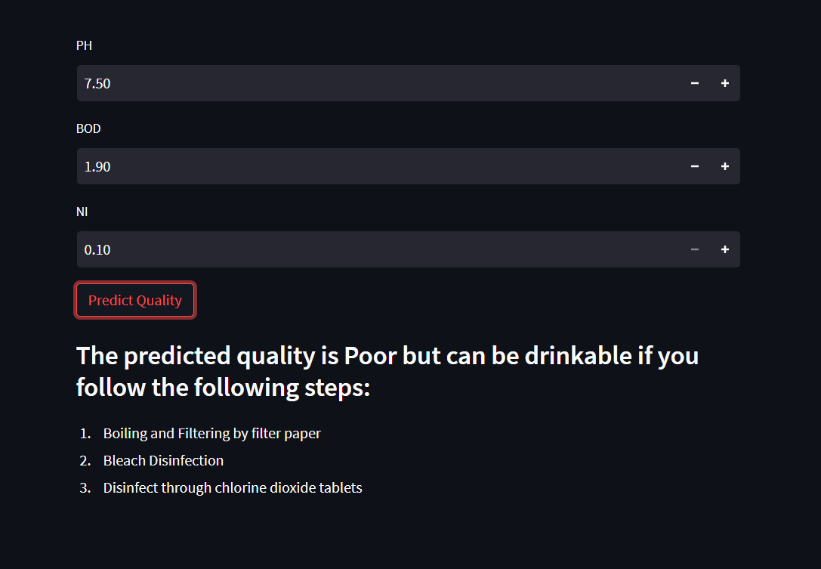~~

**Fig 13.1 Home page for authorized users with more functionality**

**~~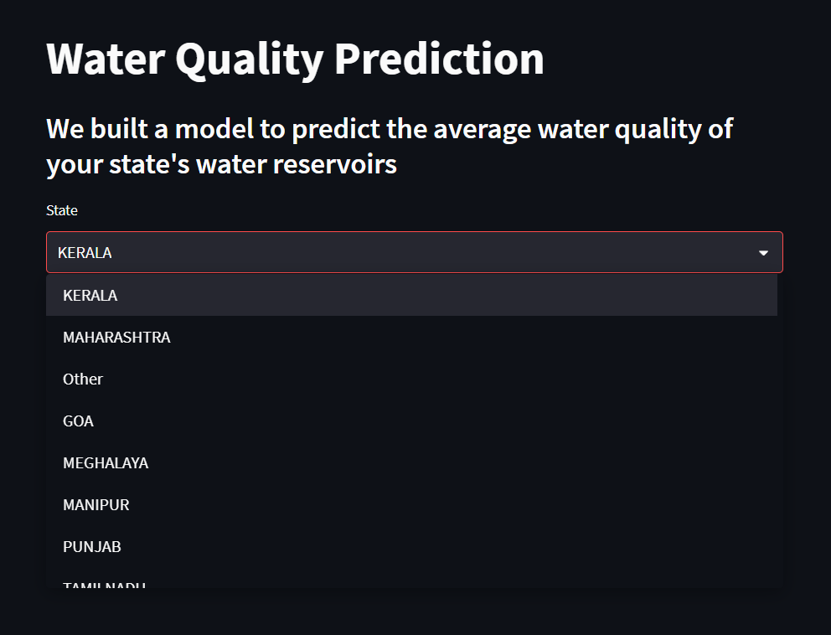~~**

~~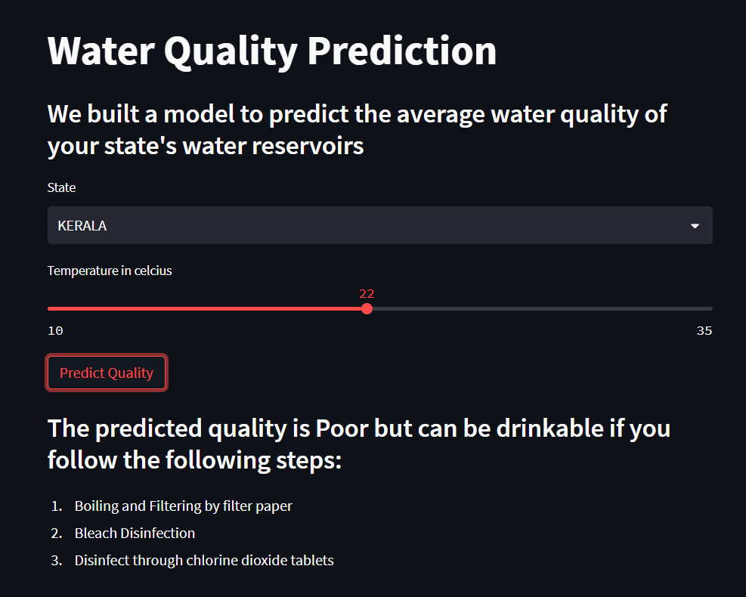~~

**Fig 13.2. Prediction page for naive users**

Predicting water quality based on a dataset using Linear Regression. The user only has to select the state and the temperature of the water body of their state.

**Potential users of a water quality predictor:**

1. **Homeowners**: Homeowners may use a water quality predictor website to check the quality of their drinking water and determine if any treatment is necessary. They may also use the website to identify potential sources of water contamination in their area.
2. **Industrial facilities**: Industrial facilities may use a water quality predictor website to ensure that the water they use in their processes is of sufficient quality. They may also use the website to identify potential sources of water contamination in their area.
3. **Agricultural producers**: Agricultural producers may use a water quality predictor website to check the quality of the water they use for irrigation and to ensure that it is safe for use on their crops.
4. **Municipalities**: Municipalities may use a water quality predictor website to monitor the quality of the water in their distribution systems and to identify potential sources of contamination
5. **Environmental organizations**: Environmental organizations may use a water quality predictor website to monitor the quality of water in rivers, lakes, and other bodies of water. They may also use the website to identify potential sources of pollution and to advocate for stronger environmental regulations.

## 5. Results and Analysis

The usage of AI in water quality and treatment prediction & usage classification can result in several significant benefits in the water industry.

1. Improved Accuracy: AI models can process large amounts of data from various sources and provide more accurate predictions compared to traditional methods.
2. Real-Time Monitoring: AI models can monitor water quality and treatment processes in real-time, alerting operators to potential problems before they become serious.
3. Cost-Effective: AI models can reduce the cost of water treatment and quality prediction by optimizing processes and reducing the need for manual labor.
4. Enhanced Decision-Making: AI models can provide water treatment and quality predictions that can be used to make informed decisions, reducing the risk of costly mistakes.
5. Automation: AI models can automate many water treatment and quality prediction processes, reducing the need for human intervention and increasing efficiency.
6. Increased Awareness: AI models can provide data-driven insights into the water treatment and quality prediction process, increasing public awareness and promoting sustainability.

Using AI in the water industry provides many benefits, but challenges remain in ensuring data accuracy, developing robust models, and making models accessible and understandable to stakeholders. However, continued advances in AI technology are likely to overcome these challenges, leading to even greater benefits in the future.

Effective algorithms such as SVM/SVR, Improved Decision Tree, Random Forest, Artificial Neural Networks, CNN, DNN, Fuzzy algorithms, and Genetic Algorithms can be used for water quality prediction, water treatment prediction, and water use case suggestion. Proper implementation of these techniques could reinvent the water sector. However, challenges exist in finding the best datasets and processing information from various sources, making it necessary for significant industrial entities with data and resources to adopt the suggested solution.

In this project, we have implemented two Machine Learning models: First for normal users which makes use of linear regression to predict the water quality using parameters location and temperature. The accuracy for the model is 95.5% ; The second model is for officials who have access to authorized data like DO, PH, Nitrogen, BOD content of the water bodies which makes use of XGBoost algorithm to predict the water quality using various quality parameters. The accuracy of the model is 95.5%.

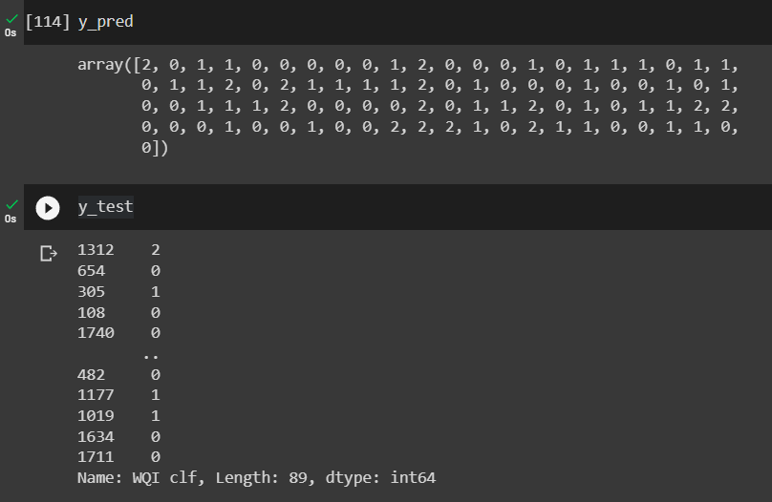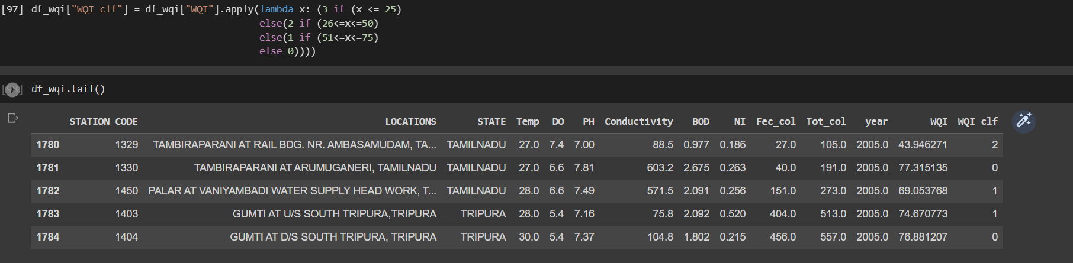  
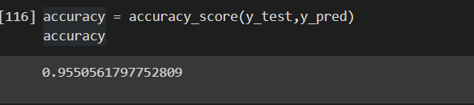

## 6. Conclusion and Future Work

Using AI in the water industry provides many benefits, but challenges remain in ensuring data accuracy, developing robust models, and making models accessible and understandable to stakeholders. However, continued advances in AI technology are likely to overcome these challenges, leading to even greater benefits in the future.

Effective algorithms such as SVM/SVR, Improved Decision Tree, Random Forest, Artificial Neural Networks, CNN, DNN, Fuzzy algorithms, and Genetic Algorithms can be used for water quality prediction, water treatment prediction, and water use case suggestion. Proper implementation of these techniques could reinvent the water sector. However, challenges exist in finding the best datasets and processing information from various sources, making it necessary for significant industrial entities with data and resources to adopt the suggested solution.

## References

1. G. Kang, J. Z. Gao, and G. Xie, “Data-Driven Water Quality Analysis and Prediction: A Survey,” 2017 IEEE Third International Conference on Big Data Computing Service and Applications (BigDataService). IEEE, Apr. 2017. doi:10.1109/bigdataservice.2017.40.
2. Zhang, Y., Li, X., Li, Y., & Ren, J. (2019). A review of artificial intelligence-based methods for water quality monitoring and prediction. Journal of environmental management, 243, 453-469.
3. Aldhyani, T. H. H., Al-Yaari, M., Alkahtani, H., & Maashi, M. S. (2020). Water Quality Prediction Using Artificial Intelligence Algorithms. Applied Bionics and Biomechanics, 2020, 1–12. https://doi.org/10.1155/2020/6659314
4. Kamyab-Talesh, F., Mousavi, S. H., Khaledian, M., Yousefi-Falakdehi, O., & Norouzi-Masir, M. (2019). Prediction of Water Quality Index by Support Vector Machine: a Case Study in the Sefidrud Basin, Northern Iran. Water Resources, 46(1), 112–116. https://doi.org/10.1134/s0097807819010056
5. He, Z., Liu, J., & Lu, X. (2020). Artificial intelligence-based water quality prediction models: A review. Water Research, 170, 115467.
6. Liu, W., & Li, Y. (2019). Artificial intelligence for water quality monitoring and prediction: a review. Environmental Science and Pollution Research, 26(16), 15891-15902.
7. Peiris, H. M. H., & Xiong, Y. (2018). Artificial intelligence techniques for water quality prediction: A review. Journal of Cleaner Production, 185, 193-209.
8. Qasem, N.A.; Mohammed, R.H.; Lawal, D.U. Removal of heavy metal ions from wastewater: A comprehensive and critical review. Npj Clean Water 2021, 4, 36. [CrossRef]
9. Wei, H., Zhang, H., & Fang, J. (2019). Deep learning models for wastewater treatment plant operational process prediction. Journal of Cleaner Production, 213, 380-388.
10. Yuan, Y., Wang, W., & Li, Y. (2019). Real-time operational process prediction in wastewater treatment plants using machine learning algorithms. Journal of Environmental Management, 243, 796-805.
11. Chang, X., & Dai, Y. (2019). Artificial intelligence-based wastewater treatment plant optimization: A review. Journal of Cleaner Production, 210, 986-1003.
12. Liu, X., Guo, Y., & Li, S. (2020). Artificial intelligence-based wastewater treatment prediction model based on improved particle swarm optimization algorithm. Journal of Cleaner Production, 269, 122509.
13. Jin, Y., Zeng, X., Wang, X., & Han, X. (2020). Deep learning-based prediction of the wastewater treatment process. Journal of Cleaner Production, 266, 122053.
14. Wang, X., Jiao, L., Zhang, X., & Li, B. (2020). Deep learning-based prediction of the treatment effect of anaerobic sequencing batch reactor for municipal wastewater treatment. Environmental Science and Pollution Research, 27(6), 6390-6400.
15. Lin, L., Fan, Y., & Li, X. (2020). Predictive control for wastewater treatment plants based on a deep neural network.Water Research, 170, 115426.
16. Wei, L., Liu, Y., & Zhang, Y. (2020). Artificial intelligence-based wastewater treatment optimization: A review. Water Research, 180, 115886.
17. Li, X., Li, Y., & Liu, J. (2020). Artificial intelligence-based wastewater treatment plant operational process prediction using convolutional neural network. Journal of Cleaner Production, 259, 120508.
18. Zhang, H., Wu, J., & Fan, X. (2020). Artificial intelligence-based water usage prediction in the chemical industry: A case study. Journal of Cleaner Production, 266, 122032.
19. Chen, S., Dong, X., & Jia, J. (2019). Predictive control for industrial water usage based on machine learning algorithms. Journal of Cleaner Production, 211, 574-581.
20. Xiong, H., He, H., & Lu, Y. (2020). An improved water usage prediction method for industrial production based on deep learning. Journal of Cleaner Production, 257, 120234.
21. Liu, X., Guo, Y., & Li, S. (2020). Water usage prediction in the chemical industry based on improved particle swarm optimization algorithm. Journal of Cleaner Production, 270, 122524.
22. Wei, L., Liu, Y., & Zhang, Y. (2020). Artificial intelligence-based water usage prediction in the chemical industry: A review. Water Research, 180, 115886.
23. Cetin, M. (2019). Water Usage Prediction by Using Machine Learning Algorithms. In International Conference on Advanced Technologies, pp. 123-127.
24. Murugesan, K., Elumalai, E., & Palaniswamy, M. (2020). Water Usage Prediction Using Machine Learning Techniques. In Proceedings of the 2020 International Conference on Computational Intelligence and Data Science, pp. 113-119.
25. Sun, S., Chen, W., & Lei, Y. (2019). A novel water-use prediction method based on an extreme learning machine and multi-objective optimization algorithm. Journal of Cleaner Production, 225, 144-153.
26. G. Kang, J. Z. Gao, and G. Xie, “Data-Driven Water Quality Analysis and Prediction: A Survey,” 2017 IEEE Third International Conference on Big Data Computing Service and Applications (BigDataService). IEEE, Apr. 2017.

### *****